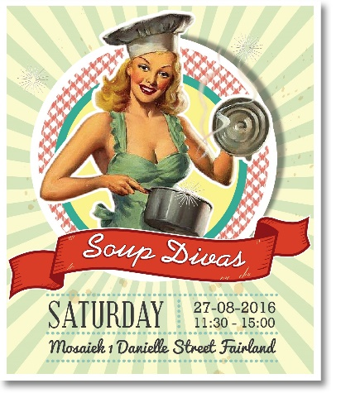 | HOSTESS DETAILS  NAME  SURNAME  CELL PHONE  EMAIL A  DDRESS
HOSTESS ENTRY FORM

YES! I would like to enter my special soup and stand the chance to be crowned the SOUP DIVA 2016!
By entering I agree to the following:
I will prepare my special soup for the event (enough for my 10 guests and 5 samples for judges)
I will decorate my own table and supply own cutlery and crocker and glasses for my table
I will invite my own guests and take responsibility for collecting their attendance fee of R 150 pp

At stake - more than R 20 000 worth of prizes!  (1st, 2nd and 3rd prize)!  Host for the day is Anrich Herbst, with guest speakers Monique Strydom and Riekies Huisamen (Kokkedoor)  Special appearance - Johan Anker – The Voice Finalist.  Fantastic lucky draw prizes to be won!  Gift bag for each guest.  Designers market. | 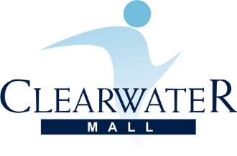  Plus stand chance to win holiday for 10  People in Barra Mozambique!

Main prize sponsors:
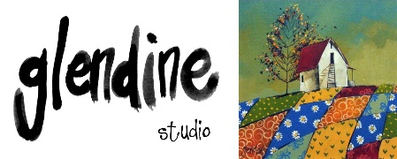 | Claris by Gerrit Pienaar | Chic Bella

Product sponsors:
 | 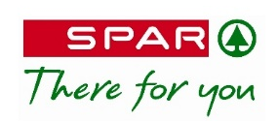 | 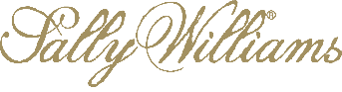

COMPETITION RULES:
- You can enter any soup dish you wish too.
- Each hostess must decorate her own table and supply table cloths, cutlery, crocker, glasses and water jugs - this can be in a theme supporting your dish. Round black table cloths will be supplied.
- There is no kitchen facilities – so soups must be prepared in advance. There will be tables and power points. You are welcome to supply hot trays (please bring own power leads) to keep the soups warm.
- The soups will be judged by a panel of judges and their decision will be final. A first, second and third prize will be awarded, as well as the Most Creative Table (Decor).
- Tables can be set up on Friday (26 August) from 12:00 – 15:00 or Saturday (27 August) from 08:00 – 10:00. Please contact Lizel if you have questions in this regard. Tel : 073 1711031.
- Matla A Bana will supply the following additionals:
- Sherry on arrival.
- Juice and water for the tables. Hostesses please supply glass jugs for juice.
- Designer breads/rolls and small butter.
- Coffee station.
- Cupcakes for each table.
- Lucky draw items.
- Gift bags.

All proceeds to be donated to:

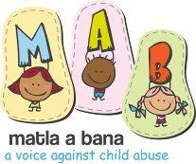 | www.matlaabana.co.za

BANK DETAILS:
Bank: ABSA Bank Limited
Branch Code: 632005
Account Name: Matla A Bana
Account Number: 4058505741

A R 500 deposit will confirm your entry. The outstanding balance to be paid by 20 August 2017.

Please email your entry and proof of payment to Lizel at matla@mweb.co.za For more info please contact Lizel Tel 073 1711 031.

PRIZES:
1ST PRIZE : Glendine Collectors Painting (R10 000) Plus R500 worth additional prizes
2ND PRIZE: Gerrit Pienaar Claris Designers Outfit (R 6000) Plus R 700 worth additional prizes.
3RD PRIZE: Chic Bella Personal Growth Course (R2500) Plus R 700 worth additional prizes.
DEST TABLE: Giorgio Trobec Painting Plus R 500 worth additional prizes.

(Please note that prizes is subject to sponsorship and might be replaced with prize worth same value)

